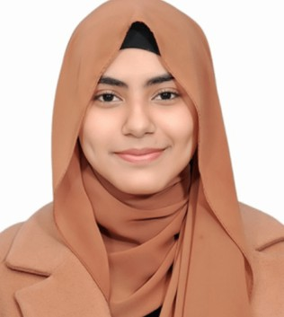



ALEESHA PERVAIZ MUGHAL

+03361547965
aleeshaness@gmail.com
Nabeel Street, Shalley Valley, Street 3, Rawalpindi

Education
Matriculation (Science)
The Educators, Range Road, Rawalpindi
Passing year: 2024
Marks Obtained: 889/1100
Intermediate (ICS)
KIPS College, Saddar, Rawalpindi
Passing year: 2026
Marks Obtained: 431/510 (Part-I)
Exp ertise
Graphic designing Reporting
Writing Management
Lan guage
English (Fluent) Urdu (Intermediate)
St udent

Profile
Self-driven and meticulous person with good communication, analytical, and organizational abilities. Recognized for my adaptability, sense of responsibility, and readiness to learn. I am looking for chances where I can put my knowledge into practice.

Experiences

Graphic Designer
Experienced in designing graphics with Canva and creating digital illustrations using a drawing tablet. Successfully worked with international clients through Fiverr, delivering creative, high-quality designs while maintaining strong communication and professionalism.

Social Media Content Creation
Experienced in video editing using DaVinci Resolve and CapCut, creating engaging and polished content for a variety of projects. Skilled in editing, transitions, color correction, and delivering high-quality videos with attention to detail.

Public Speaking, Debates, MUNs & Research
Experienced in MUNs with strong research and content writing skills. Served as Class Representative and Proctor, improving communication and organization. Skilled in creating clear, well-structured, and well-researched written content.

Google Workspace & Document Specialist
Expert with Google Workspace tools such as Docs and Sheets, with experience in writing well-structured reports and creating spreadsheets. Competent in organizing, formatting, and documenting data. A fast and accurate typist who is detail-oriented and efficient.

Quranic Recitation & Academic Tutor
Experienced in Quranic recitation and Tajweed, developed through strong academic background and upbringing in Saudi Arabia, where foundational learning was completed. Also provides subject tutoring with a focus on clear explanation, student understanding, and academic improvement across multiple subjects.

